**Week 4**

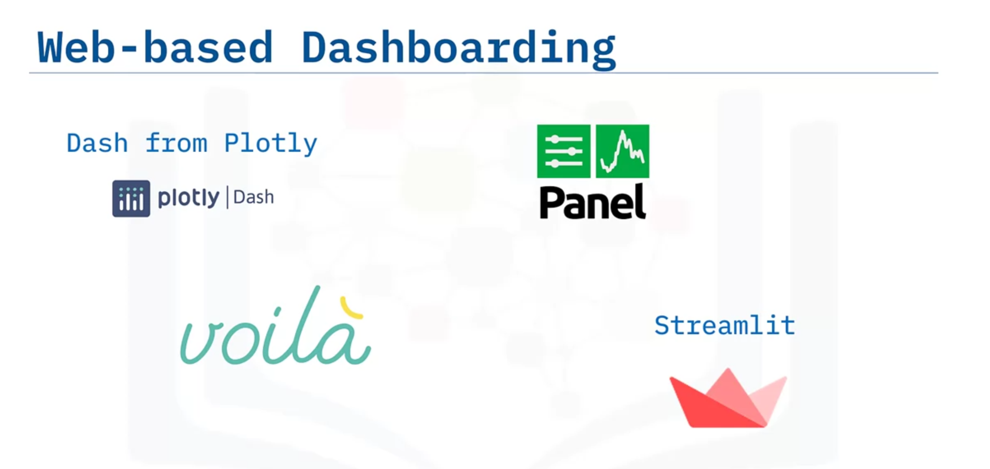 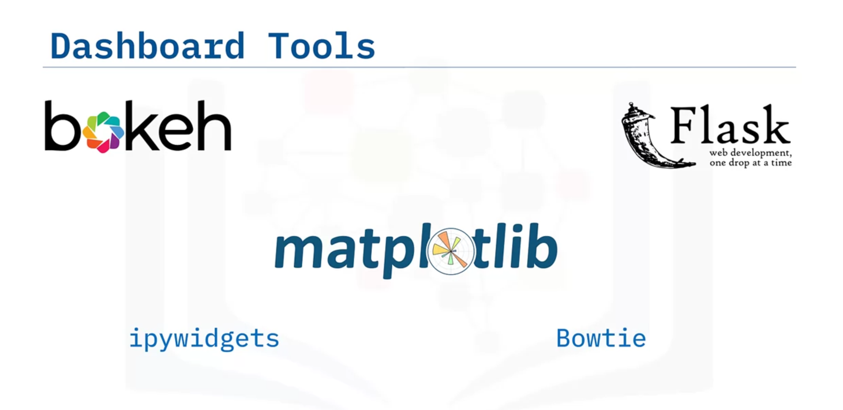

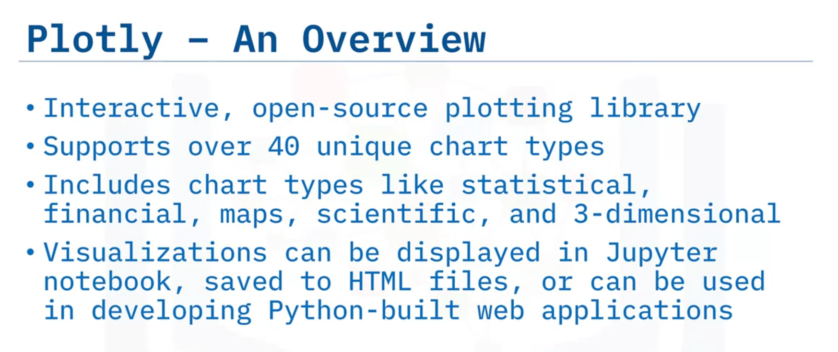

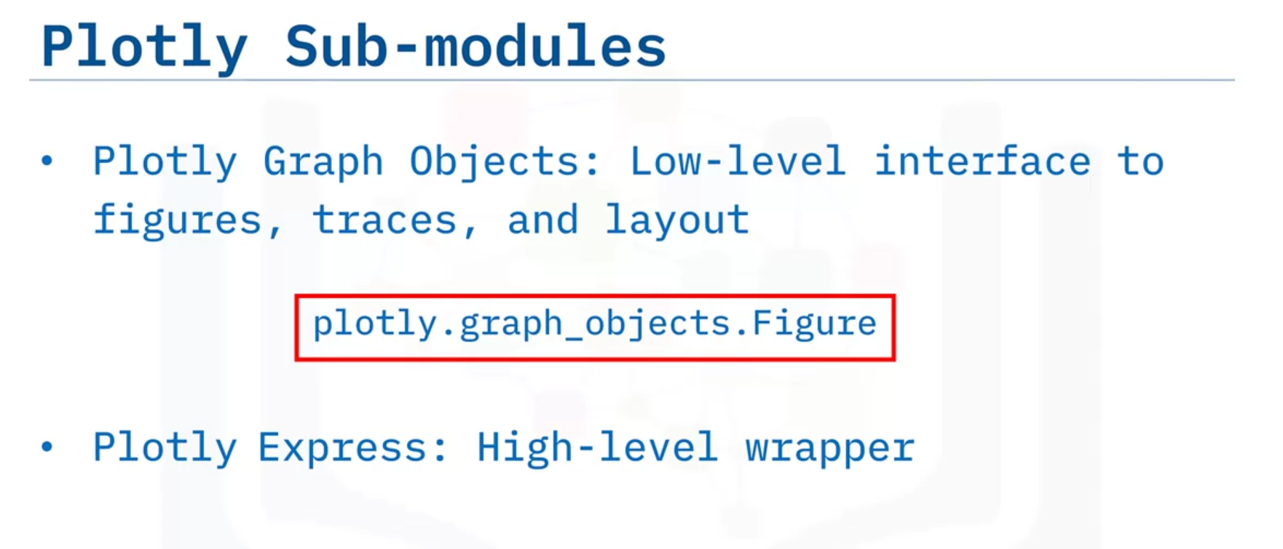 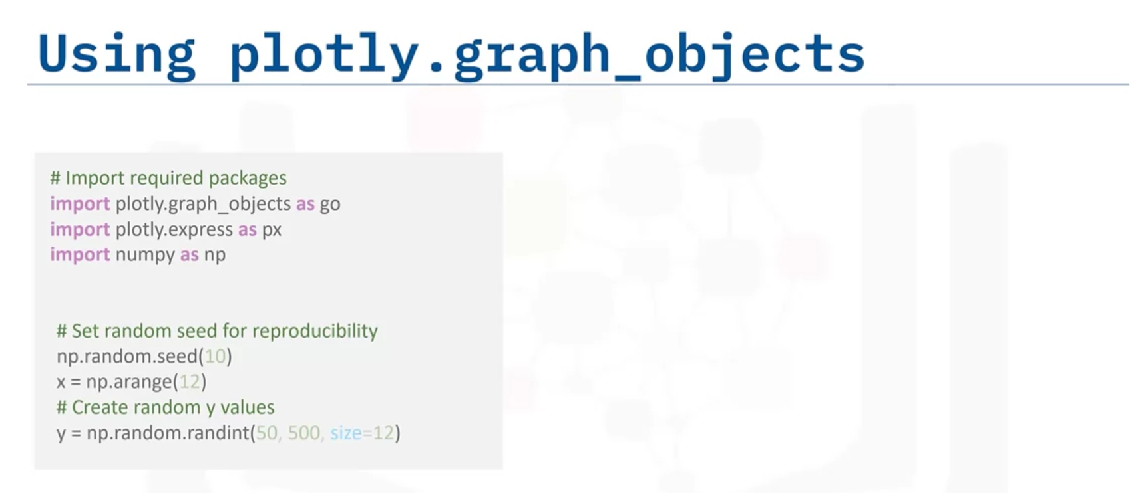

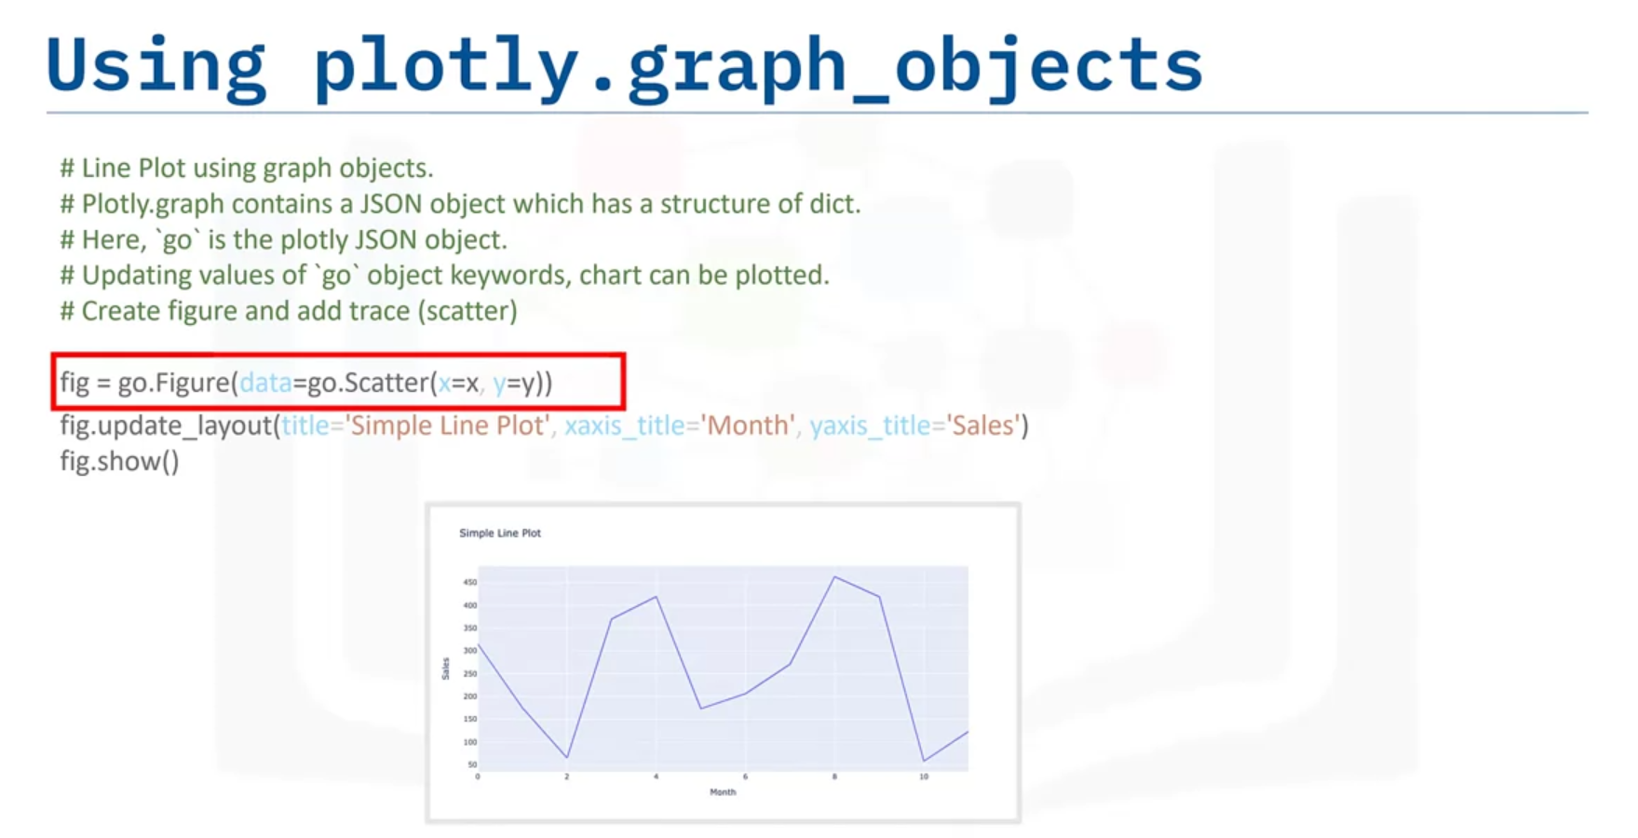

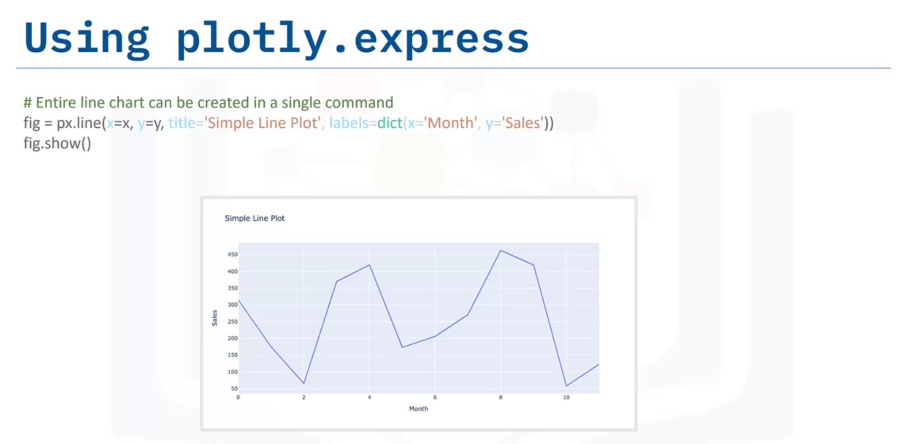

# Additional Resources for Plotly

To learn more about using Plotly to create dashboards, explore

[Plotly python](https://plotly.com/python/getting-started/)

[Plotly graph objects with example](https://plotly.com/python/graph-objects/)

[Plotly express](https://plotly.com/python/plotly-express/)

[API reference](https://plotly.com/python-api-reference/)

Here are additional useful resources:

[Plotly cheatsheet](https://images.plot.ly/plotly-documentation/images/plotly_js_cheat_sheet.pdf)

[Plotly community](https://community.plotly.com/c/api/5)

[Related blogs](https://plotlygraphs.medium.com/)

[Open-source datasets](https://developer.ibm.com/exchanges/data/)

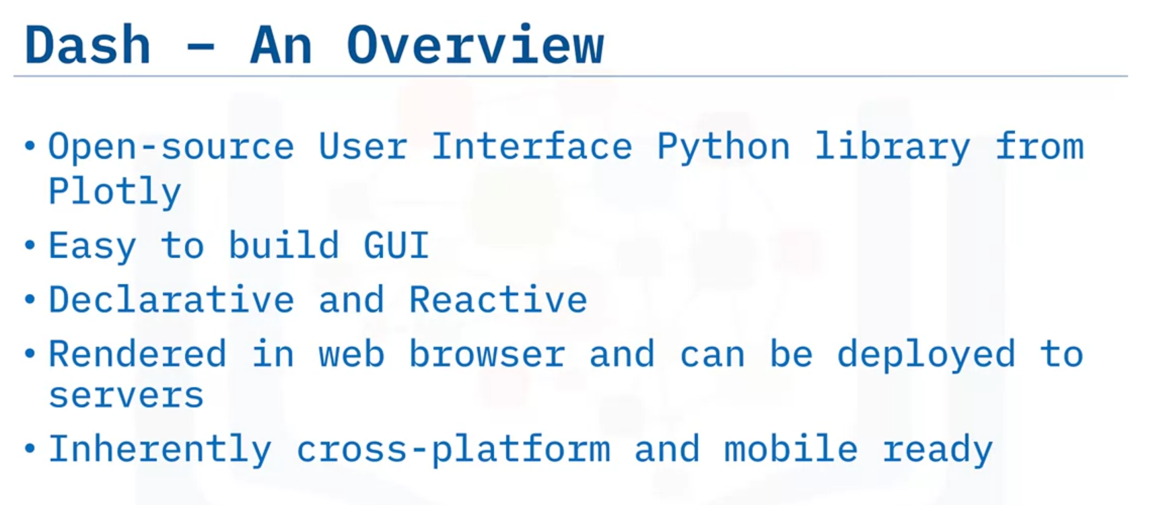

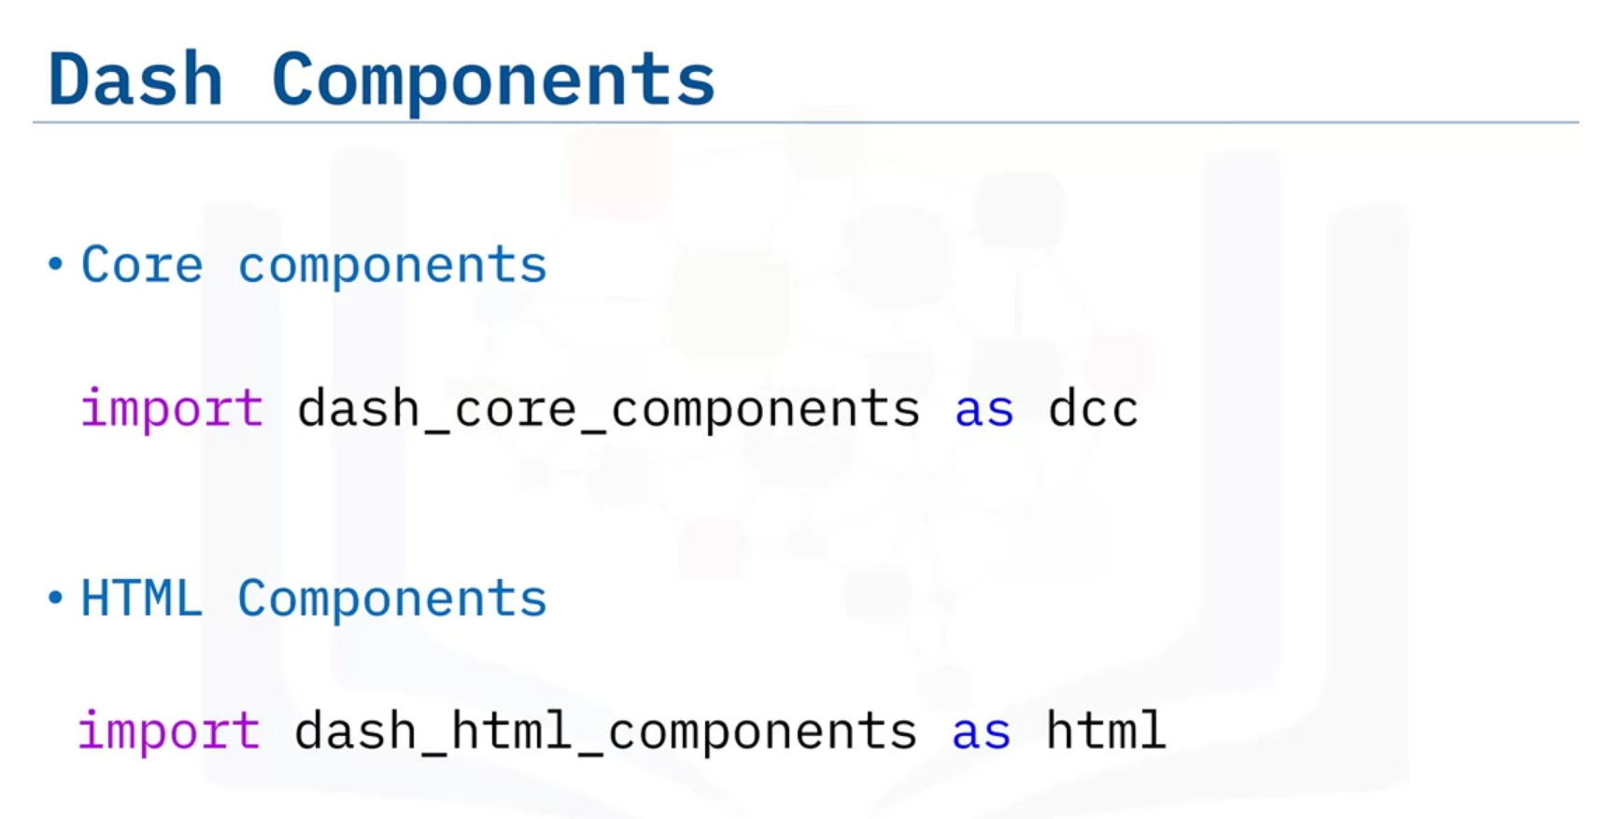

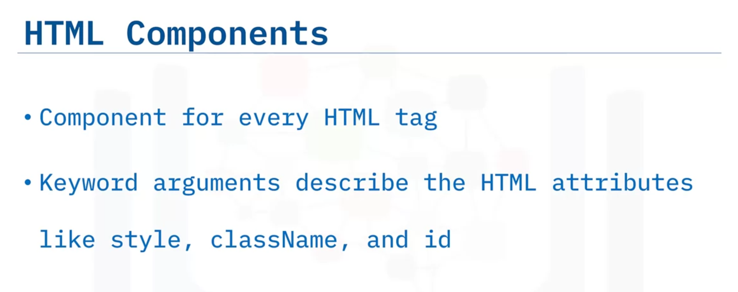

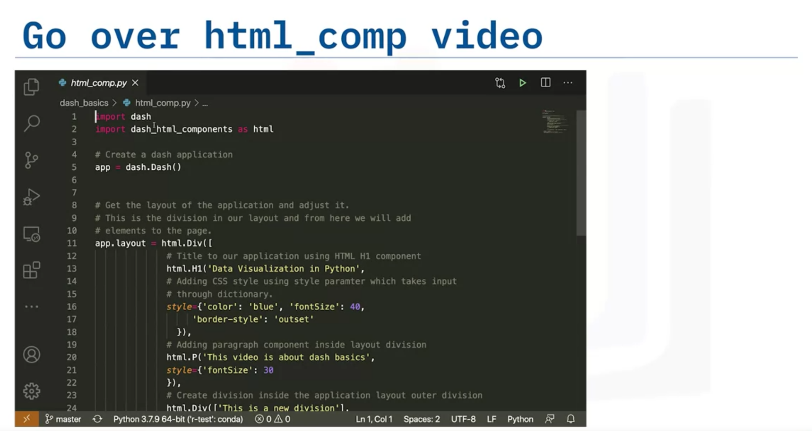

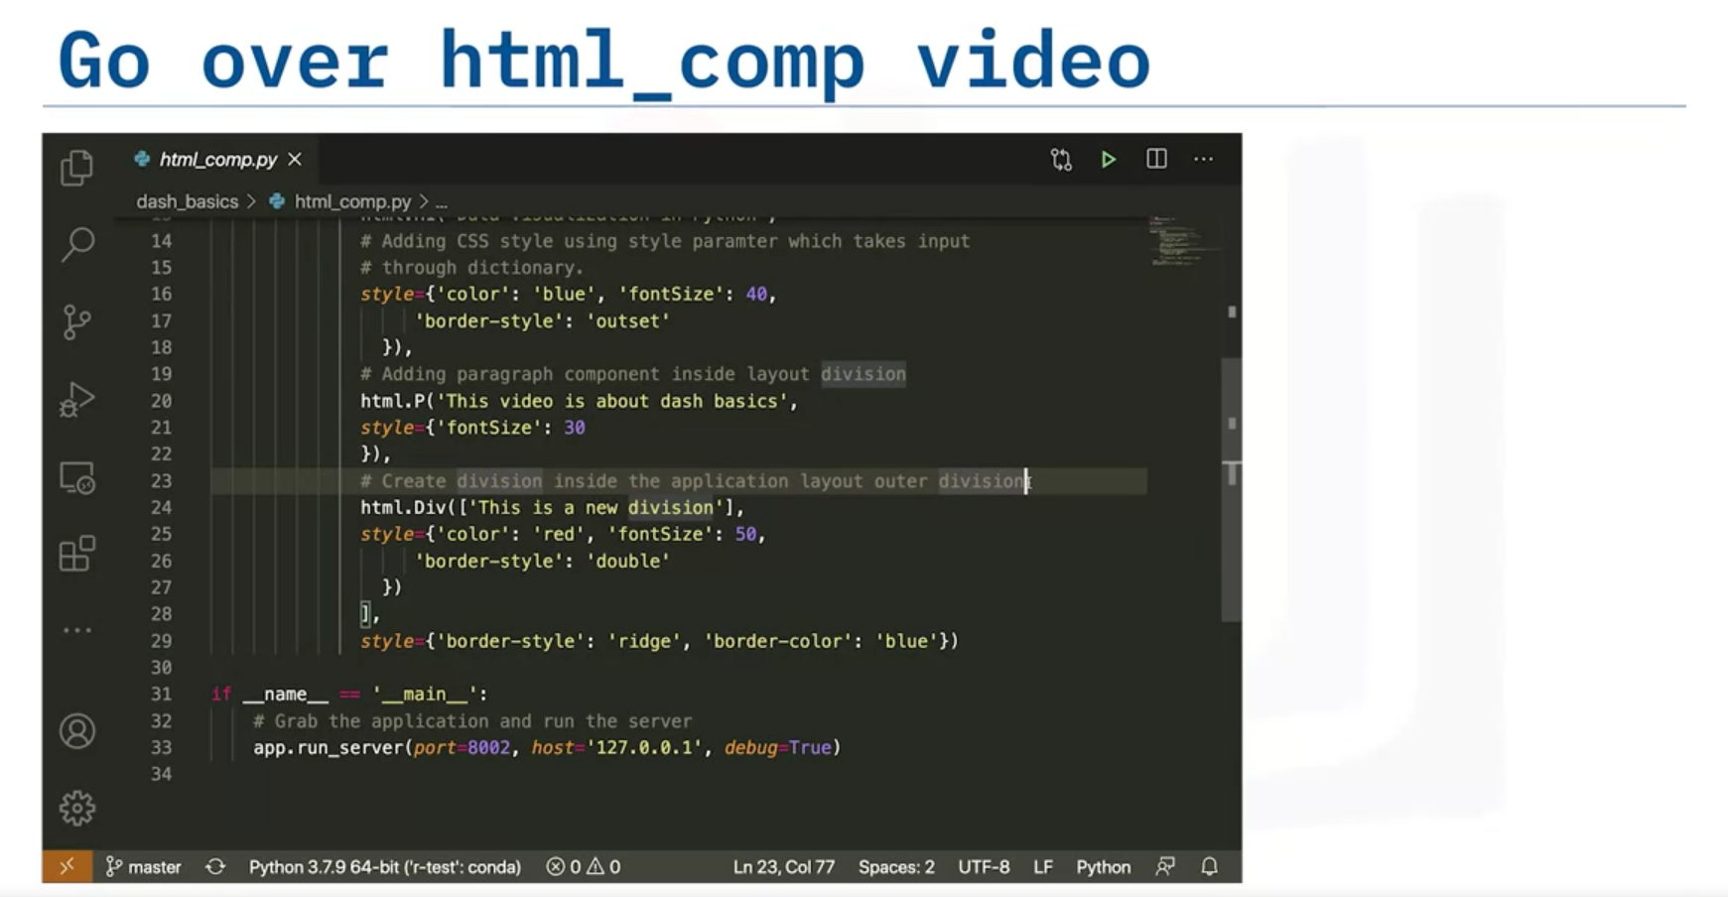

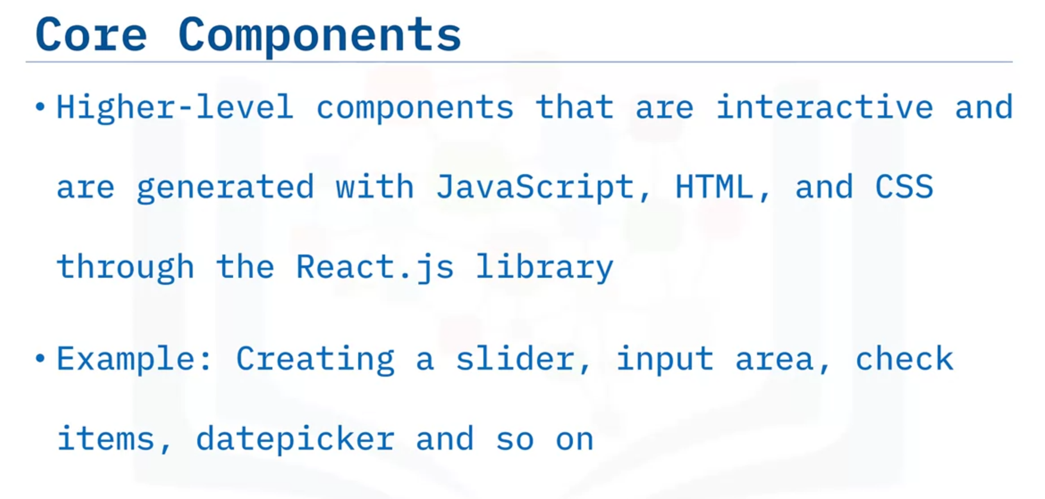

# Additional Resources for Dash

To learn more about Dash, explore

[Complete dash user guide](https://dash.plotly.com/)

[Dash core components](https://dash.plotly.com/dash-core-components)

[Dash HTML components](https://dash.plotly.com/dash-html-components)

[Dash community forum](https://community.plotly.com/c/dash/16)

[Related blogs](https://medium.com/plotly/tagged/dash)

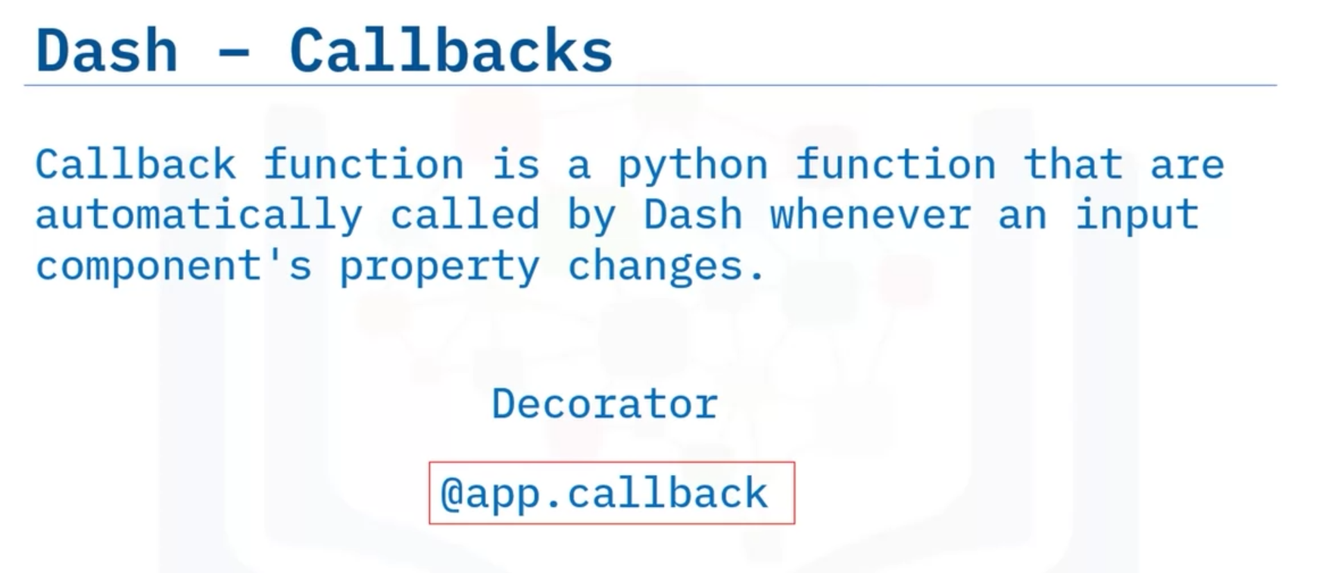

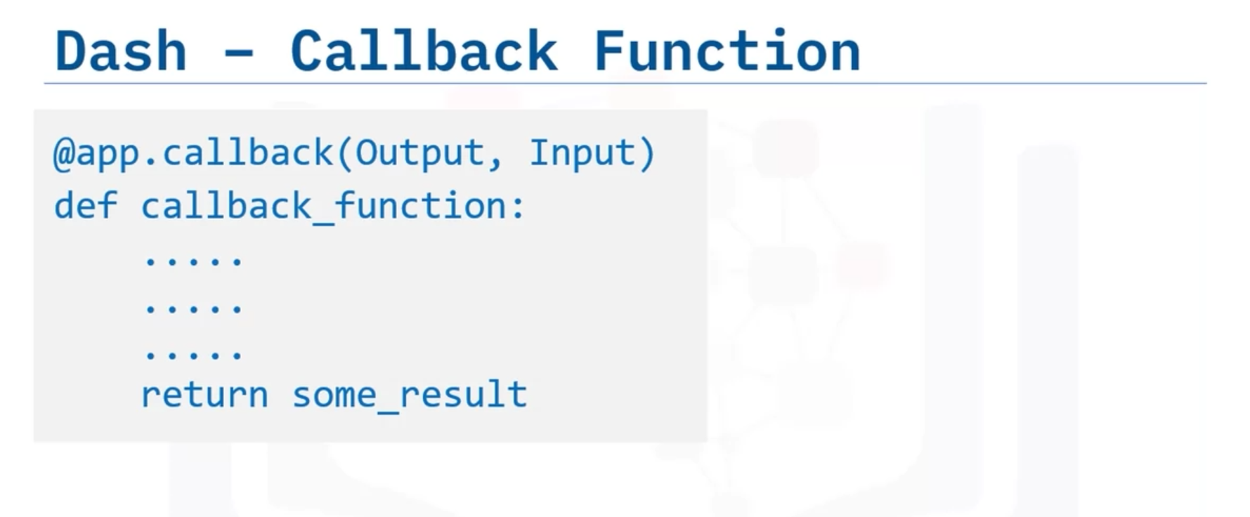

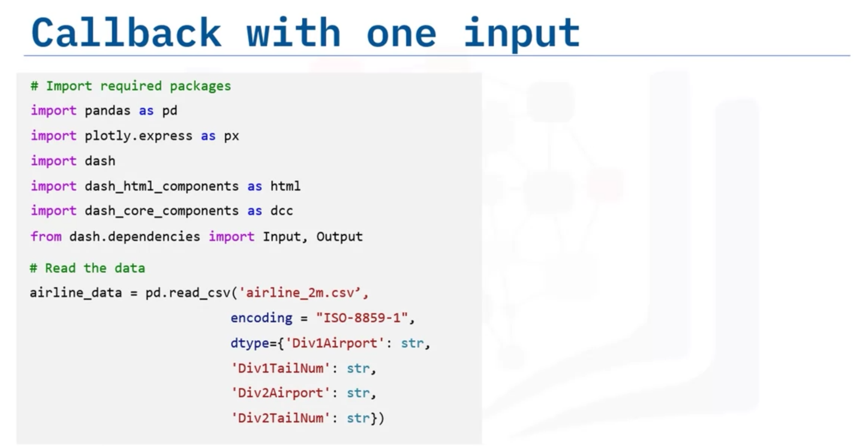

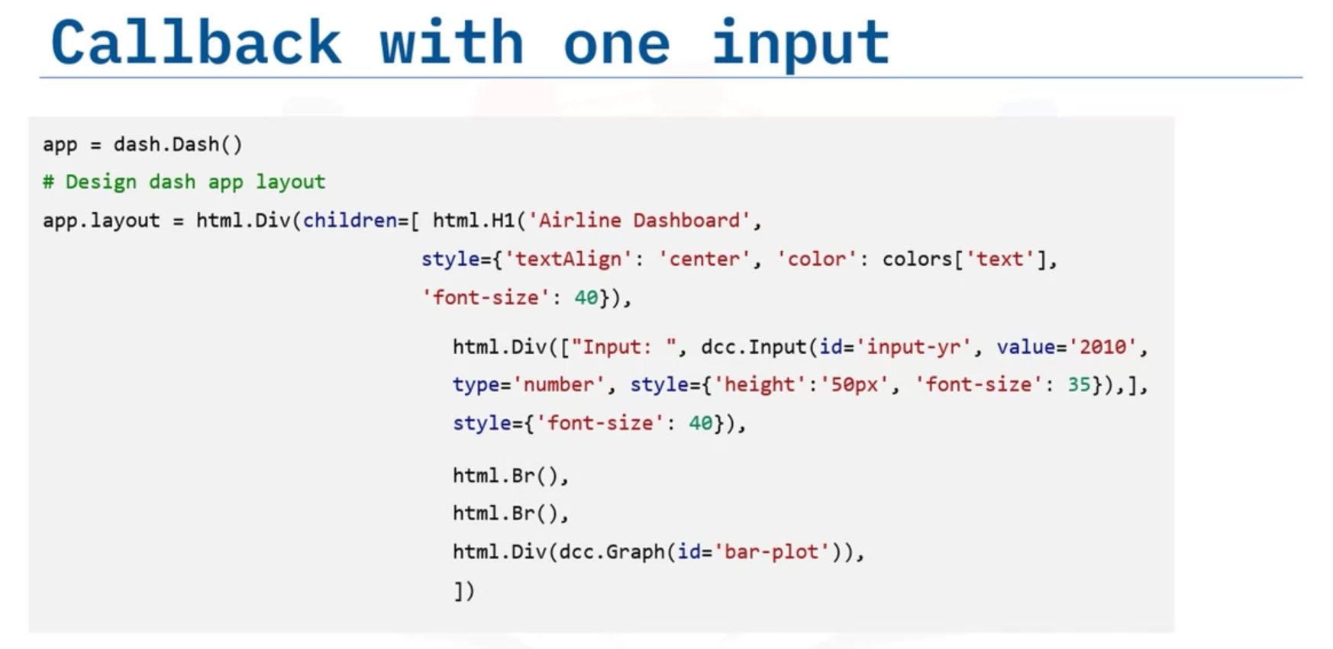

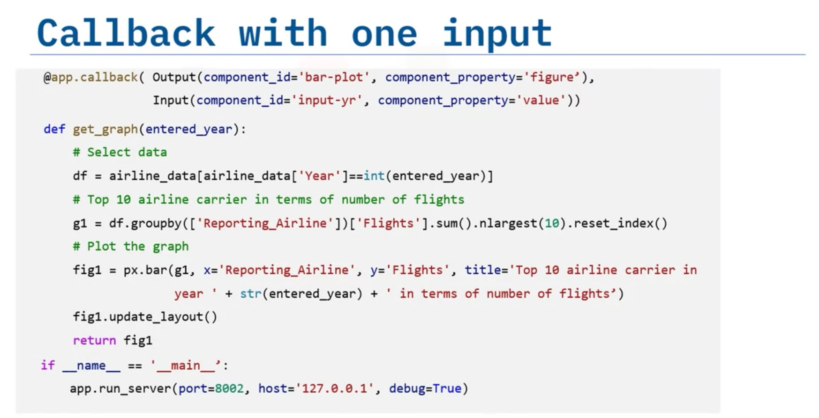

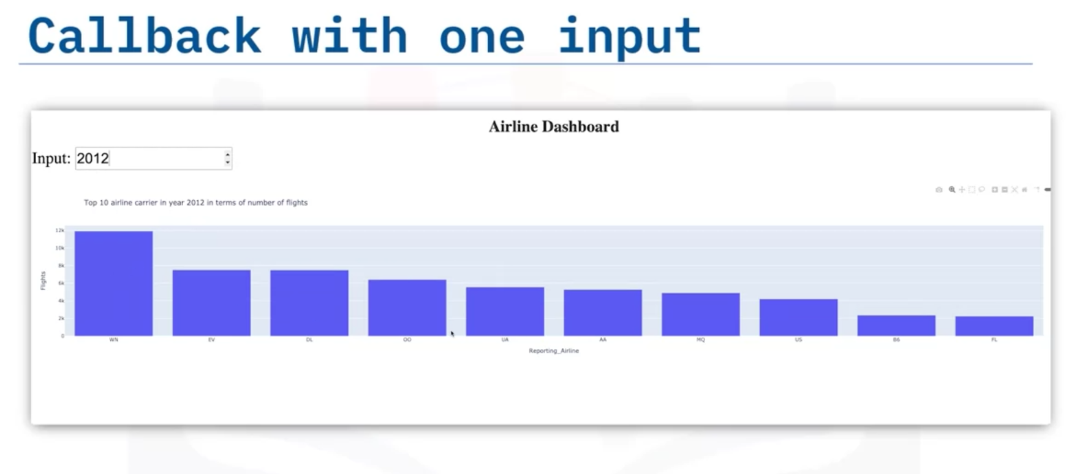

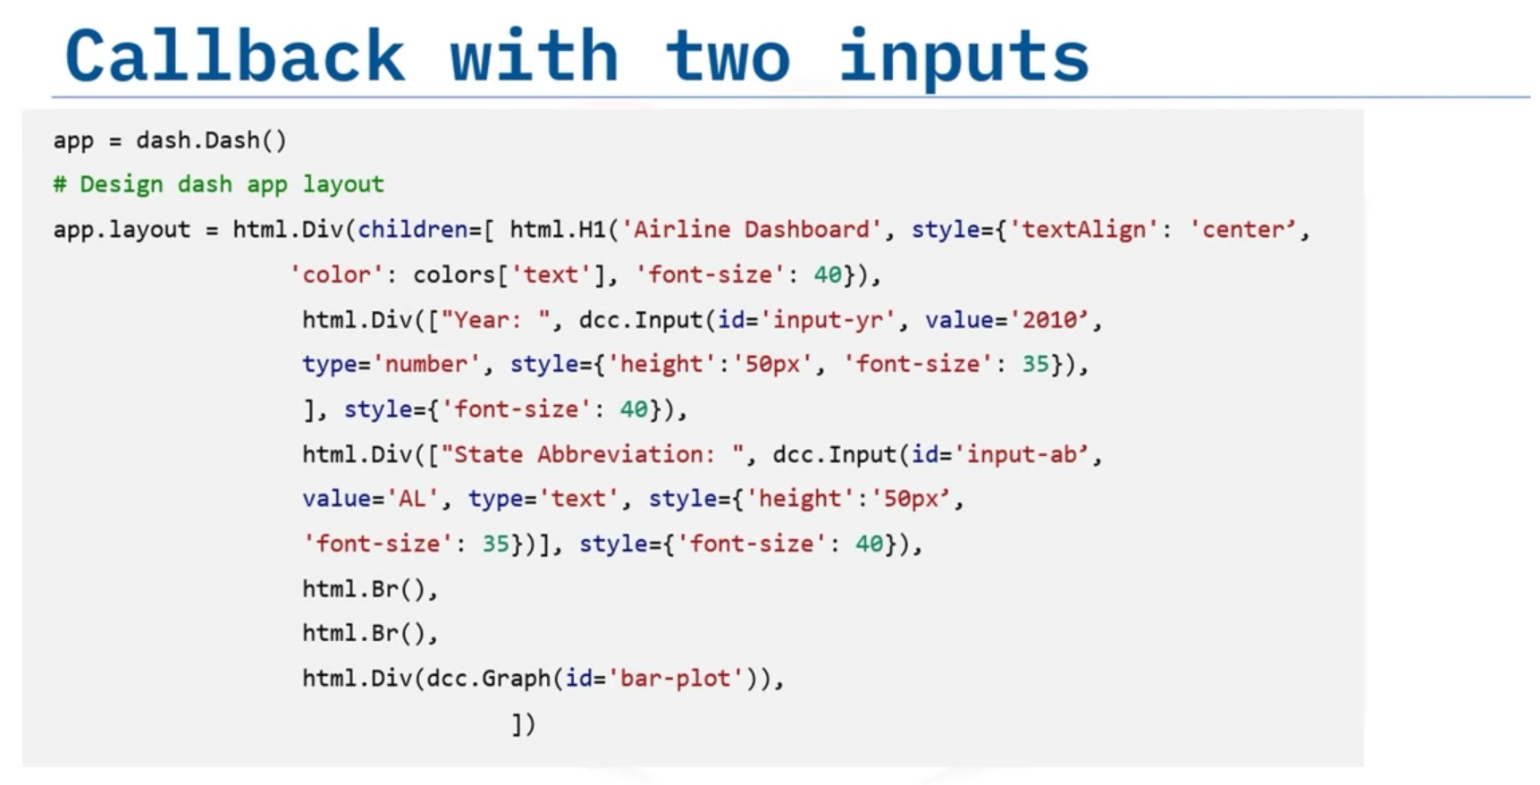

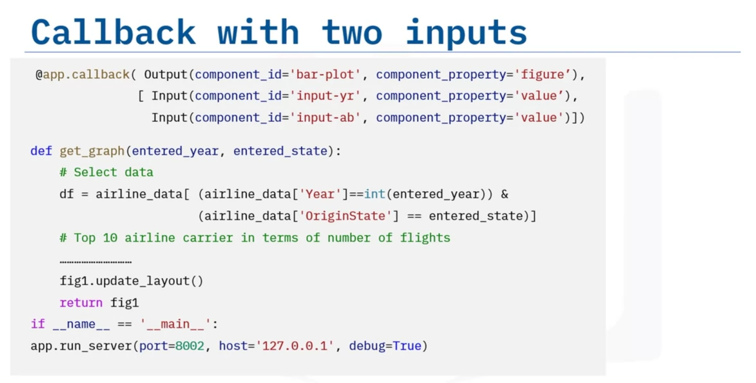

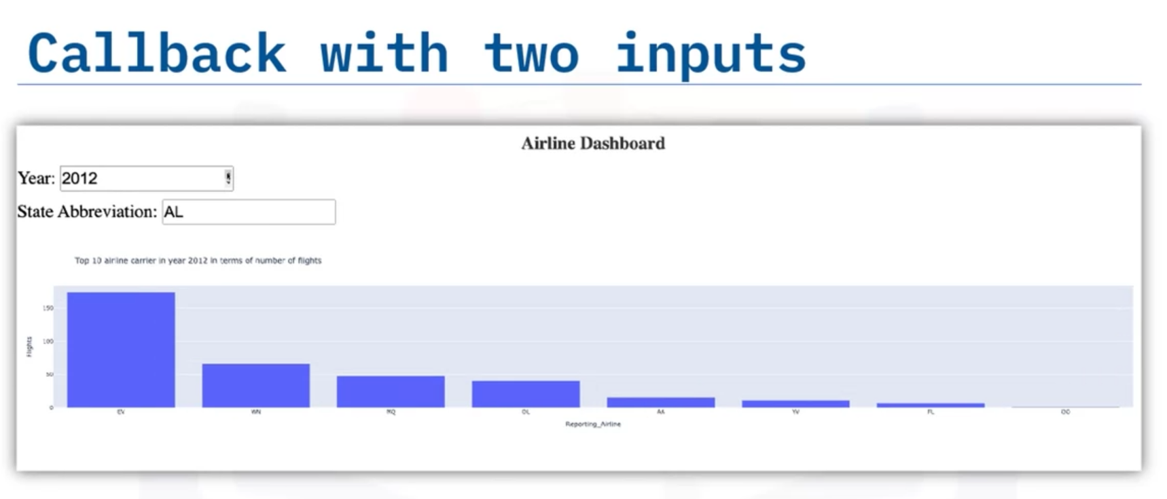

# Additional Resources for Interactive Dashboards

To learn more about making interactive dashboards in Dash, visit

[Python decorators reference 1](https://realpython.com/primer-on-python-decorators/)

[Python decorators reference 2](https://www.python.org/dev/peps/pep-0318/#current-syntax)

[Callbacks with example](https://dash.plotly.com/basic-callbacks)

[Dash app gallery](https://dash-gallery.plotly.host/Portal/)

[Dash community components](https://plotly.com/dash-community-components/)

# Lesson Summary

* Best dashboards answer critical business questions. It will help business make informed decisions, thereby improving performance.
* Dashboards can produce real-time visuals.
* Plotly is an interactive, open-source plotting library that supports over 40 chart types.
* The web based visualizations created using Plotly python can be displayed in Jupyter notebook, saved to standalone HTML files, or served as part of pure Python-built web applications using Dash.
* Plotly Graph Objects is the low-level interface to figures, traces, and layout whereas plotly express is a high-level wrapper for Plotly.
* Dash is an Open-Source User Interface Python library for creating reactive, web-based applications. It is both enterprise-ready and a first-class member of Plotly’s open-source tools.
* Core and HTML are the two components of dash.
* The dash_html_components library has a component for every HTML tag.
* The dash_core_components describe higher-level components that are interactive and are generated with JavaScript, HTML, and CSS through the React.js library.
* A callback function is a python function that is automatically called by Dash whenever an input component's property changes. Callback function is decorated with `@app.callback` decorator.
* Callback decorator function takes two parameters: Input and Output. Input and Output to the callback function will have component id and component property. Multiple inputs or outputs should be enclosed inside either a list or tuple.